Genesis Assesment

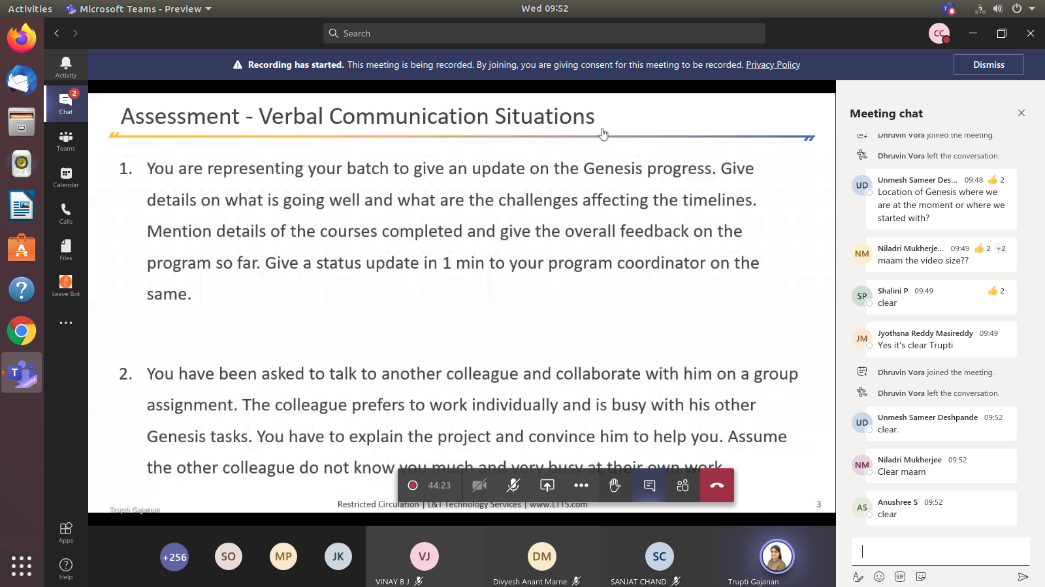
Video:

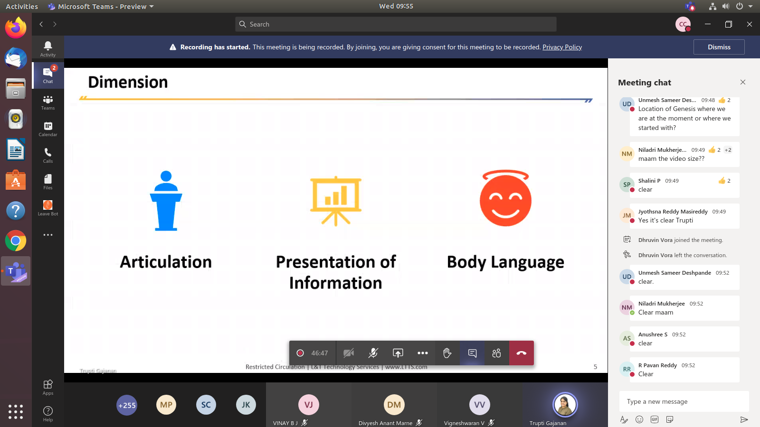

Body Launguage: Refer the ATL Courses, Youtube
Presentation: Refer the ATL Courses, Youtube
Articulation: Refer some Youtube videos and ATL Courses

PSNO. First_Name.

Email:

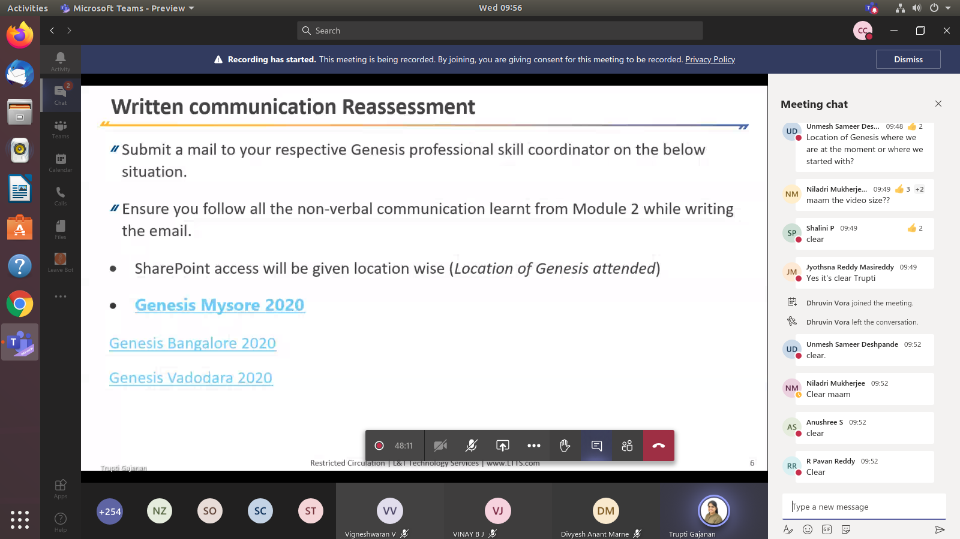
3 -4 phara – 3-5 lines

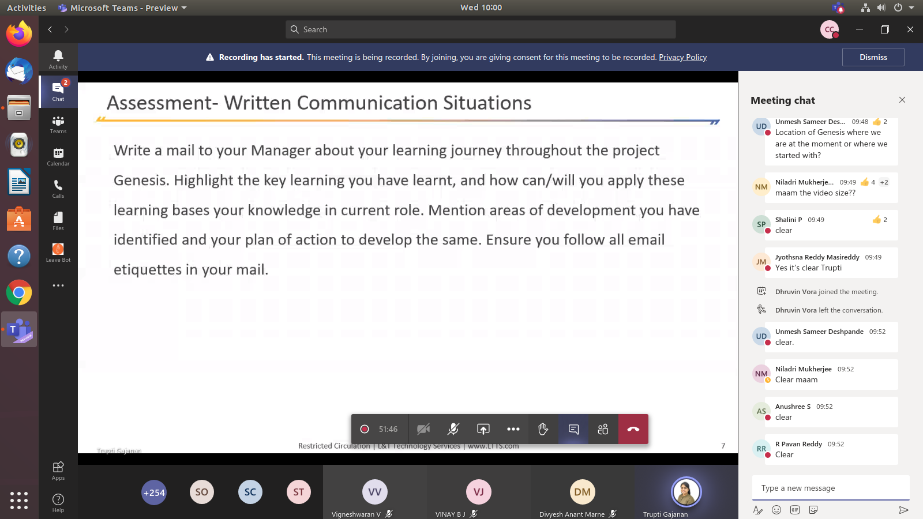
Email to the Mudasar: [emailId]

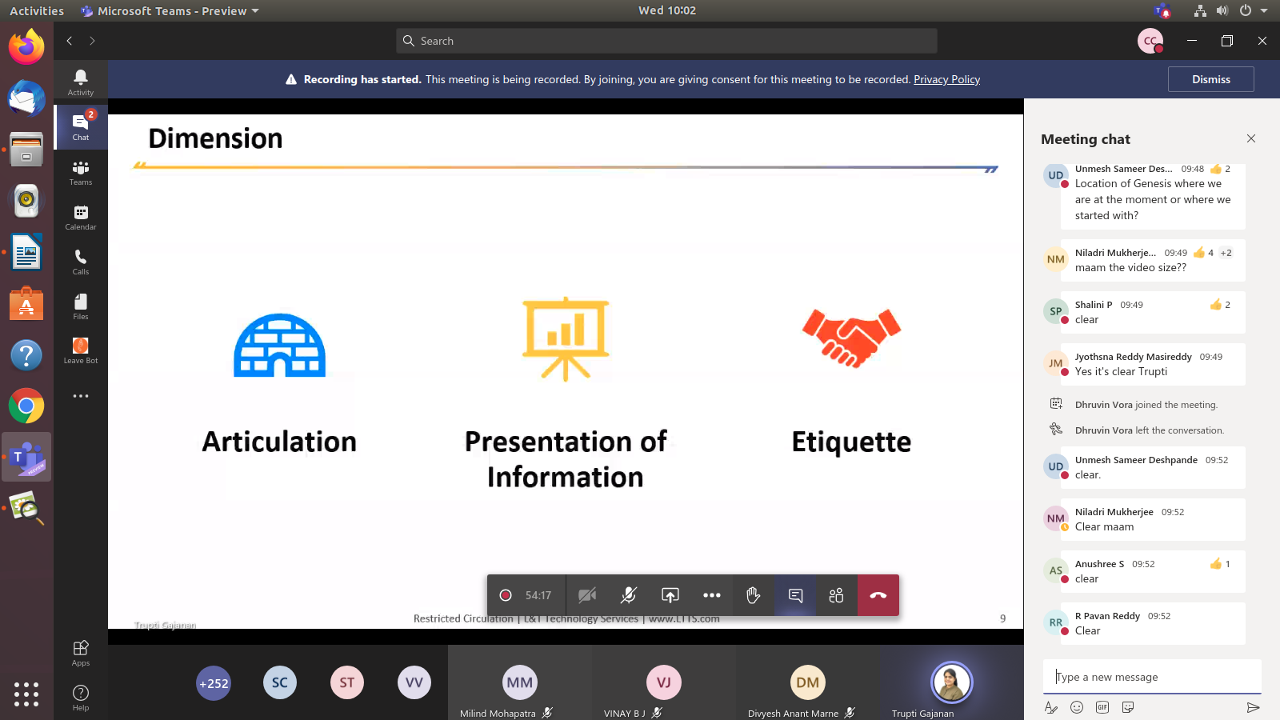
Body Launguage: Refer the ATL Courses, Youtube
Presentation: Refer the ATL Courses, Youtube
Articulation: Refer some Youtube videos and ATL Courses

Firday 1 PM Deadline

PSNO. First_Name.docx

